|  |  |
| --- | --- |
| EGC_Black | Student Name \_\_\_\_\_\_\_\_\_\_\_\_\_\_\_\_\_\_\_\_\_\_\_    **Eastern Goldfields College**  Mathematics U1 2017  Assignment – Calculator Free1 |
|  | **Time allowed: 20 minutes** Total Marks: 15 marks |

***Answer all of the following questions. Show all working to obtain full marks.***

Question 1 (9 marks)

(a) At a certain time of day, the shadow of a 2 m tall post is 3.8 m long. Determine, at the same time of day, the length of the shadow of a tree that is 5 m tall. (3 marks)

(b) The two triangles shown below are similar. Determine the lengths  and . (3 marks)

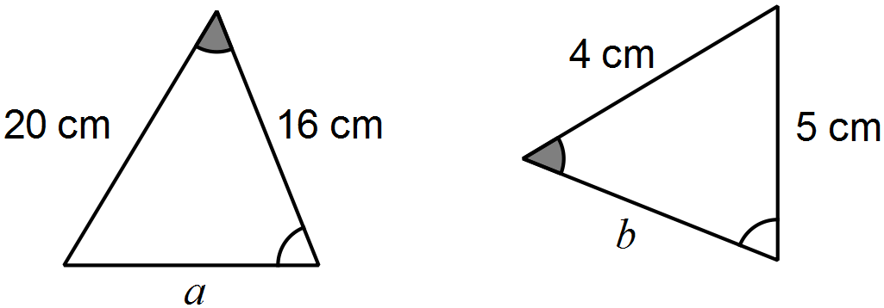

(c) An image, with one side that is 17 cm long, is enlarged so that the same side now measures 51 cm. If the original area of the image was 250 cm2, determine the area of the enlargement. (3 marks)

Question 2 (6 marks)

A system of one-way and two-way paths connects three locations A, B and C. There may be more than one path between any two locations. The table below shows the number of ways to travel between these locations using a single path.

|  |  |  |  |  |
| --- | --- | --- | --- | --- |
|  |  | To | | |
|  |  | A | B | C |
| From | A | 0 | 1 | 1 |
| B | 0 | 0 | 2 |
| C | 2 | 2 | 0 |

(a) Is the path between A and B one-way or two-way? Justify your answer. (1 mark)

(b) Complete the network diagram below to show the information in the table. (2 marks)

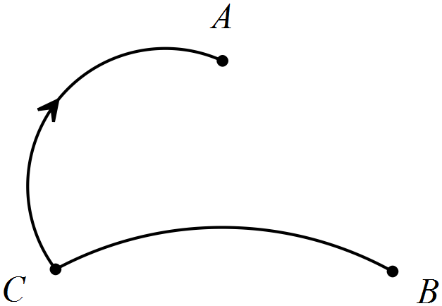

(c) Arrange the information from the table in a matrix  and determine the matrix . (3 marks)

|  |  |
| --- | --- |
| EGC_Black | Student Name \_\_\_\_\_\_\_\_\_\_\_\_\_\_\_\_\_\_\_\_\_\_\_    **Eastern Goldfields College**  Mathematics U1 2017  Test 2 – Calculator Assumed1 |
|  | **Time allowed: 20 minutes** Total Marks: 17 marks |

**Calculator only permitted for this section, no notes.**

***Answer all of the following questions. Show all working to obtain full marks.***

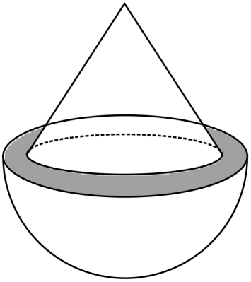

Question 1 (9 marks)

A solid cone of radius 12 cm and height 16 cm is placed   
symmetrically atop a solid hemisphere of radius 14 cm   
to form the composite solid shown right.

(a) Use Pythagoras' Theorem to calculate the   
slant height of the cone. (1 mark)

(b) Determine the area of the grey shaded ring, between the cone and the hemisphere, as shown in the diagram above. (2 marks)

(c) Determine the surface area of the composite solid. (3 marks)

(d) Calculate the volume of the composite solid. (3 marks)

**Question 2 (8 marks)**

(a) The standard cash fares on a public transport system are related to how many sectors that a user travels through, as shown in the table below.

|  |  |  |  |  |  |  |
| --- | --- | --- | --- | --- | --- | --- |
| Sectors | 1 | 2 | 3 | 4 | 5 | 6 |
| Cash fare | 2.90 | 4.40 | 5.20 | 6.20 | 7.70 | 8.70 |

(i) A user who buys a book of 25 tickets in advance is offered a 15% discount. How much would such a book of tickets cost for 3-sector journeys? (2 marks)

(ii) A user with a TravelCard is entitled to a 25% discount on all fares if the TravelCard is automatically topped up by direct debit. How much does such a user save in a week when they make seven 1-sector journeys, two 2-sector journeys and one 6-sector journey?

(2 marks)

(iii) The cash fares include 10% GST. How much GST is included in the 5-sector cash fare?

(1 mark)

(c) The sales assistants at an electrical retailer are paid a weekly retainer of $725 plus 8% commission on the total value of the goods that they sold during a week.

(i) Calculate the weekly pay for a sales assistant who sold $18 520 worth of appliances during a week. (1 mark)

(ii) Another sales assistant had a weekly pay of $1931. Determine the value of appliances that this person sold. (2 marks)